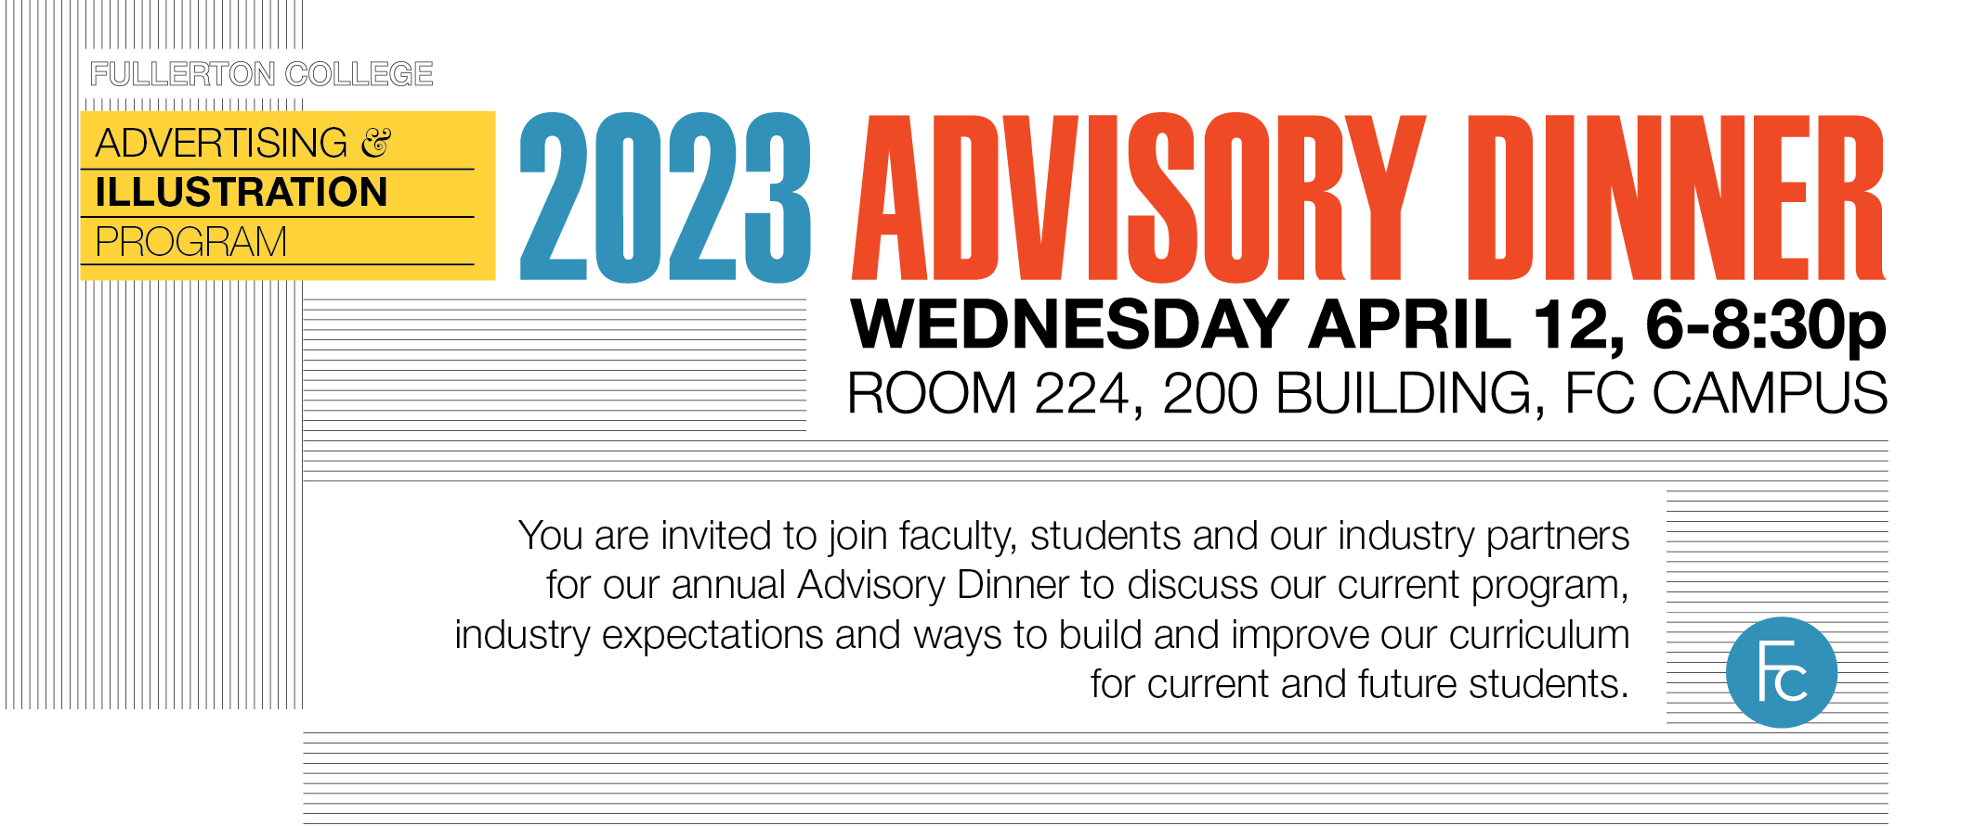
Illustration Certificate Programs
Advisory Committee Dinner Meeting
April 12th, 2023
6PM, Room 224

Minutes of the Meeting

Advisory Committee Members present:
Jim Dowdalls. Freelance Medical Illustrator; Full-time faculty, Fullerton College; lead person for CTE Illustration programs at FC.
Frank Guthrie. Lead faculty for Animation and 3-d programs, DART full-time Faculty, Fullerton College.
Mike Sheehan. Freelance Designer and Illustrator; Full-time faculty, Fullerton College
Youngsun Cho. Art Director, Kelly Toys, Intl.
Brian Crosby. Director of Marvel Themed Entertainment Development, Illustrator and educator
Marshall Vandruff. Freelance Artist and online educator; Adjunct Faculty, Fullerton College
Oliver Laguette, Student representative, Illustration Certificate

New Business:

Updated/Revised Certificates:
The group was advised that the Illustration Certificate and the Children’s Book Illustration Certificate are both going through a major Revision by DART Faculty member, Frank Guthrie, in order to change the unit count in the Cartooning Course, ART 144 F and the Fashion Sketching course, ART 139 F, from 2 units to 3, so that the courses may be approved for transfer to CSU and UC institutions. The ART 144 F course is a restricted elective in both certificates, and the ART 139 F course is a restricted elective in the Illustration Certificate. These revisions are currently in the Curricunet system for the approval process, for implementation in Fall 2024.
The vote was taken to approve these revisions. All present voted in the affirmative for these revisions.

Frank Guthrie (FG) brought up an important topic for discussion regarding the core class situation for the Beginning Storyboard course (ART 215 F), which he is currently teaching, as an emergency substitution for adjunct faculty member Brian Murray, who was scheduled to teach the class during this Spring 2023 semester, but had to withdraw due to medical circumstances.
FG stated that many of his students in the Beginning Storyboard course were woefully underprepared for the artistic requirements of the course, particularly in their abilities to sketch the figure and linear perspective, as well as understanding and describing camera shots.

FG stated that our current and future certificates in Art and DART would benefit greatly from the creation and inclusion in the curriculum of a Foundation Certificate that would include all of the important fundamental drawing and design courses that some of the certificates currently lack, especially the Children’s Book Illustration and the Storyboarding certificates. The group discussion then focused on what current courses in Art and DART curriculums should be included. FG suggested strongly that the most important classes that our students need were the basic Drawing for Entertainment Arts, Sketching for Animators and Illustrators, and Life Drawing. Mike Sheehan and Jim Dowdalls (JD) agreed with that. FG said that he felt that the Maya 3-d class offered important skill s that our foundation students needed, JD was skeptical, and suggested that either Animal drawing or Basic design were more important course that should or could be offered in this foundation certificate. Our student representative, Oliver Laguette (OL), said that when he studied 3-d at OCHSA, he felt that it was an immense help with other classes that he was taking there at that time, as well as in his current curriculum at FC.

After a lengthy group discussion, it was decided that the courses to be included in this new foundation certificate should include:
ART 137 F Basic Drawing for Entertainment Arts
ART 157 F Sketching for Animators and Illustrators
ART 186 F Beginning Life Drawing
ART 118 F Color Theory
DART 101 F Photoshop for Digital Arts
DART 104 F Introduction to MAYA
All course are 3 units each, for a total of 18 units.

FG has offered to create this new certificate and to Shepheard it through the curriculum review process, and JD has offered to revise the three Illustration area certificates to include this new Foundation certificate as a requirement to taking the three certificates.

New Visual Storytelling certificate in Curricunet approval Process.

JD stated that FG, Mike Sheehan (MS), and Marshall Vandruff (MV) were in the process of creating a Visual Storytelling certificate, and having already introduced it into the Curricunet approval process for Fall of 2024. JD asked if that meant that the existing Storytelling courses that are offered in the Children’s Book Illustration certificate and the Storyboarding certificate needed to be removed from those certificates; both FG and MV said that was not the case, that these courses could be offered in multiple certificates.

What’s currently happening in the Industry?
FG asked the two professional members in attendance, Youngsun Cho (YC) and Brian Crosby (BC), what were their perceptions of what our students needed to be successful in the current work environment.
BC said that in his experience, most pros were using their IPads and the program Procreate, as the go-to tool for quick sketch, immediate presentations, and workflow.
YC said that she still relied on working on her Cintique at home and at the office, but was using the program Illustrator more than Photoshop. Mike Sheehan (MS) said that he felt that Illustrator was a program that was under-utilized, and in his view, just as important for our students to learn as Photoshop.
FG stated that he instructed his students on how to bring the vector-based program directly into his 3-d program Maya, as part of the workflow.

What are the biggest challenges to the success of our program? AI? Beyond AI? How can we/should we incorporate AI into our curriculum?

FG said that he is already introducing AI visual art programs into his Storyboarding class, as many of the students were not doing well in the class because of a lack of drawing and presentation skills, and AI could help supplement this lack of skills.
He also suggested that we should not create a distinct class for AI, but learn to use it in our existing classes as part of the workflow. MS agreed. Marshall Vandruff (MV) suggested that this was probably a topic for another meeting, as the discussioncould dominate the timeframe of the current meeting.

Discussion of a plan to offer and instruct the core classes in the Children’s Book Illustration and Storyboarding Certificates on a regular basis:

JD and MV said that we were on track to have offered the four Storytelling classes, as well as the Composition and Children’s Book Illustration course from the Fall of 2022 through the Fall 2024 semester, closing this cycle of each class offered within a two year period, with a new cycle starting with the Spring 2025 semester. As instructors Brian Murray and Frans Tedja Kusuma were not present at the meeting, their input into the regular offering of the Storyboarding and Advanced Illustration courses could not be discussed. It was decided to shelve this discussion for another time/meeting.

Jim Dowdalls presented new information concerning the Department and the Illustration certificates:

Strong Workforce Grants: Over the past two application cycles (two year cycles), the Illustration area has been awarded $88,000 (2020/21) and $75,000 (22/23) for Life models and Computer Lab Aides, through the Strong Workforce Grants. Also purchased, and in use: several MacMini’s and a new Cintique, as well as a new color copier for the group office. My Latest Grant was just submitted for the calendar years 2023 and 2024. The total requested was approximately $126,000 for Life models, Computer lab aides, and a new Mac Studio computer.

Guest Speakers : As this years’ Artist in Residence program budget has not been used, the absence of it allowed us to reintroduce the Visiting Artist Program to our department, so that will be included in the Spring 2023 semester; discussions and arrangements with several artists is pending at this time. Suggestions will be solicited from the committee at our Advisory meeting. It was announced in our March 16th, 23, department meeting that the department was awarded $8000 for visiting artists through our Program Review allocations, by Todd Smith.

Mike Sheehan and Phil Dimitriadis are currently sponsoring a panel discussion at the end of this month that will include five different female artist/illustrator Alumni that are all succeeding in different areas of the creative industry.

Guided Pathways: As of Fall 2021, guided pathways, the semester by semester study plans for students, have been created and implemented through the Counseling area for all three illustration Certificates: the Illustration Certificate, the Children’s Book Illustration Certificate, and the Storyboarding Certificate.
Students and interested applicants can find this pathway information under the “Academics/Degrees and Certificates: Hornet pathways” link on the schools homepage.

Meeting Adjourned

